ABINAV S T

230701007

Exp No:12 File Organization Technique

Single and two level directory

PROGRAM:

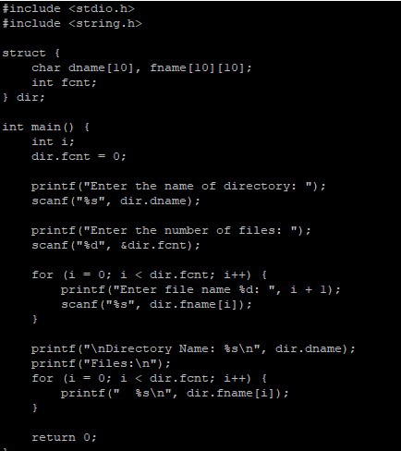

OUTPUT

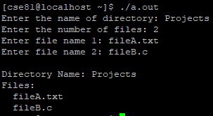

PROGRAM

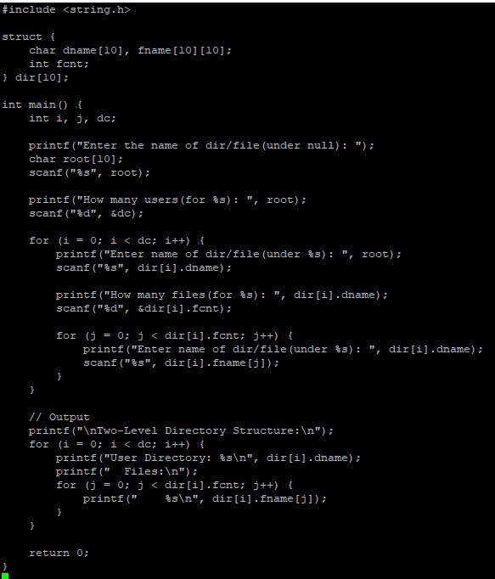

OUTPUT

